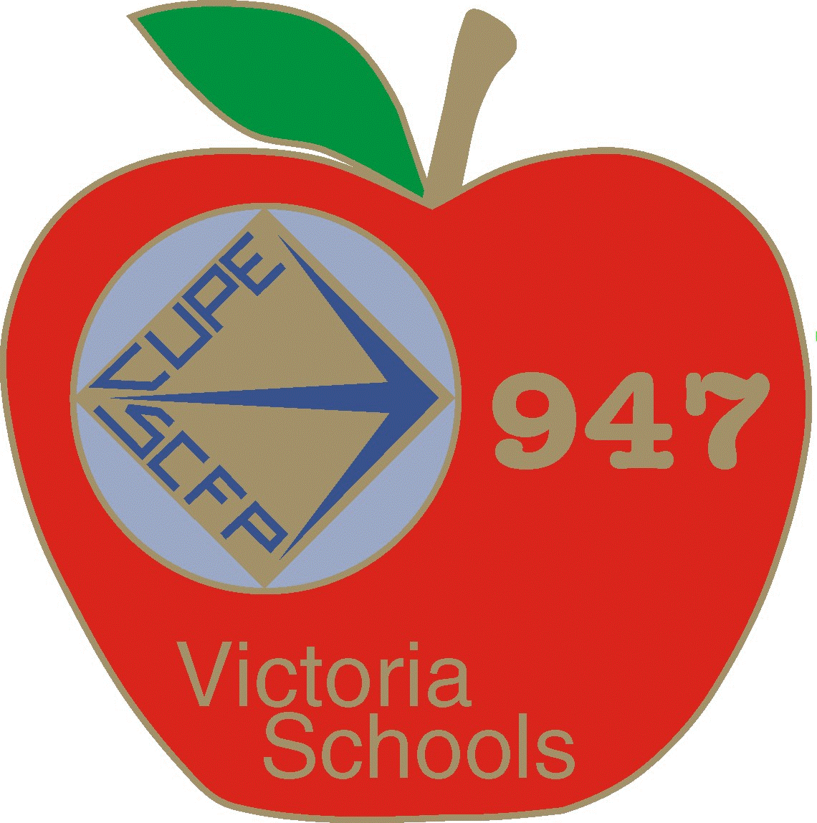**CUPE 947 BURSARY INFORMATION & CRITERIA**

CUPE Local 947 is pleased to offer 3 different Bursaries for our members and their families. Please note the new updated application form! One application form for all 3 Bursaries, please check which Bursary you are applying for.

**The Pat Keller Memorial Bursary** has been a long standing Bursary valued at $3000. Pat Keller was a long time CUPE 947 member who passed away many years ago due to cancer. This Bursary was created in her honour and is offered to a child of a member who currently holds a continuing position and is in good standing with CUPE 947.

**ELIGIBILITY**

* Must have completed Grade 12 in the current or previous calendar year.
* Must be entering post-secondary education for full time studies with proof of registration for the September start.
* Application must be filled out in full with copies of registration, tuition receipts, letter of intent, letter of reference and official start date.
* Completed Criteria Checklist handed in with completed application.

**The Karen Boettger Memorial Bursary** is another long standing Bursary valued at $3000. Karen Boettger was a long time CUPE member who tragically passed away in a motor vehicle accident on her way home from work. This Bursary is offered to a CUPE 947 member wishing to further their educational pursuits.

**ELIGIBILITY**

* Member must currently hold a continuing position and be in good standing with CUPE 947.
* Must show proof for full time studies in their application.
* Application must be filled out in full with copies of registration, tuition receipts, letter of intent, letter of reference and official start date.
* Completed Criteria Checklist handed in with completed application.

**The Lisa Barbetta Memorial Trades Bursary** is our third Bursary valued up to $2000. Lisa Barbetta was a CUPE 947 member who served as our Chief Shop Steward before she sadly passed away from Cancer.

This Bursary is offered to either a CUPE 947 member **OR** the child of a CUPE 947 member who wishes to enter a specific Trades or Vocational related career based program.

**ELIGIBILITY**

* Member must hold a continuing position and be in good standing with CUPE 947.
* Member’s child must have completed Grade 12 in the current or previous calendar year.
* Must show proof of full-time studies as prescribed by the particular program.
* Application must be filled out in full with copies of registration, tuition receipts, letter of intent, letter of reference and official start date.
* Completed Criteria Checklist handed in with completed application.

Please note - All Bursaries will be awarded by the Bursary Committee based on the application process.

An Application Criteria Checklist that must be included with your fully completed application. All required documents and information on the checklist must be submitted in hard copy to the CUPE 947 office at #113- 3550 Saanich Rd. Victoria BC V8X 1X2, no later than September 30th*** Thank you!